1. Business Invitation sample Also see page 4 for another formal invitation sample
Must contain all information items shown here.
- Erase all blue notes before print
Company / Organization Letterhead
邀请函也可以用中文写。
1
1

Date

Information about the Company /organization, or about the event
2

Information about the applicant (the person to be invited)
Name & Gender
Birth date
Passport number

Information about Travel Arrangement And visa to request
3
Type of visa (one entry / two entry / multiple entry),
Duration of stay (rough date of entering China and date of departure )

Approximate travel time
Brief description about the trip purpose and arrangement
Who covers the trip cost
Hotel arrangement if applicable, etc.

If you have any questions, please do not hesitate to contact me as shown below.

Sincerely
5
Inviter’s contact info
4
Company
Red Stamp

Representative
Inviter’s Name, title,
6
and signature
Address:
Direct phone（Must be easily reached, also Cell phone）
A fax number (Must work and can accept fax from US)

Need Original Or a colored copy, (must have the 6 critical information points)
Or at least scan to a colored PDF file,
IF Email to office@ChinaServices.us，show your Service ID

2. 探亲邀请函,每人一份 Q1 /Q2 /S1 /S2 Invitation letter sample, see next two pages
2A. 探亲邀请函,每人一份
如果邀请人是中国公民，用中文写

see 2B next page for Invitation in English。
Delete this box before use

邀请信
邀请人姓名XX，性别X，出生日期：X年X月X日，中国身份证号XXX（或外国护照号XX，中国永久居留证号XX），现在中国居住地址为XX，联系电话(手机号)XX，电邮XX。
本人现邀请以下亲属赴华短期探亲/长期居住，拟于X年X月X日赴华，停留期XX天。
被邀请人信息：姓名XX，性别X，出生日期XX，国籍XX，护照号XX，与邀请人的亲属关系为XX。

后附我中国居民身份证 （或中国合法居留证）正反面的复印件。

邀请人
（签字）

xxxx年xx月xx日于(xx)

邀请函须经签字，扫描电邮过来，打印出来，加入其他文件。One for EACH Applicant 每人一份
连同邀请人的身份证 双面复印件，

Date: 201x.xx.xx
2B. Personal Invitation in English, One for Each
Only if the inviter is an non-Chinese but
working / or legally living in China
如果邀请人是中国公民，请用中文写, 见2A
Delete this box before use
To Chinese Embassy / Consulate in US

I am living / working in China. Hereby I am inviting the following individual to visit me.

Applicant’s name （as shown in passport）
Birth date
Passport number
He / She will arrival around 20xx. xx. xx and mainly touring in ….; planned departure date is 20xx. xx. xx
He / She is my xxxxxx.

Here is my information:
Full Name:
I am currently living / working in China, living in the address:

I can be reached by the phone number xxx xxx xxxxx (visa officer may call to verify)

He/she will pay for his/her own international airfare, and I will assist the expense during his /her stay in China.

Should you have any further questions, please do not hesitate to contact me. I can also be reached by phone number in China, or by email: …………..

Sincerely Yours

Name

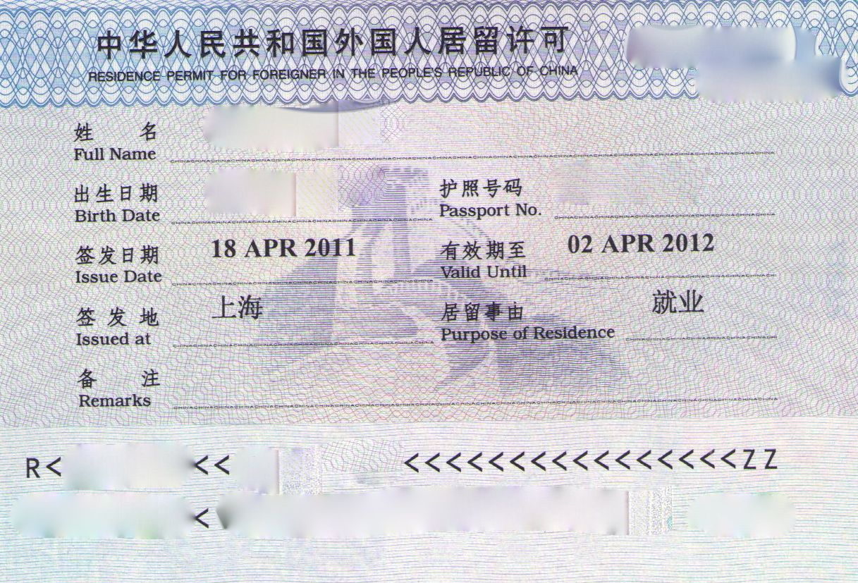

NOTE: (delete this portion before print)
This letter can be scanned and email to
applicant, add to the document package
With a copy of China ID

If a foreigner working / studying in China,
- Use the “Residence Permit for ”,
暂居证(similar to a China visa, inside passport)

- ALSO a copy of the passport photo page

Page 4: another formal Business invitation letter sample: over-write page 1 invitation letter
Authorized Unit Visa Notification Letter – Sample ONLY
